Zone 3 – Bank Area



Day | Monday | Tuesday | Wednesday | Thursday | Friday
Year Group | Year 1 (12.20 – 12.50)  Year 2 (12.50 – 1.20) | Year 3 | Year 4 | Year 5 | Year 6

Zone 4 – Basketball Area



Day | Monday | Tuesday | Wednesday | Thursday | Friday
Year Group | Year 3 | Year 4 | Year 6 | Year 2 | Year 5

Zone 6 – Football



Day | Monday | Tuesday | Wednesday | Thursday | Friday
Year Group | KS2 Girls | Year 6 | Year 5 | Year 4 | Year 3

Zone 8 – Sunshine Gym

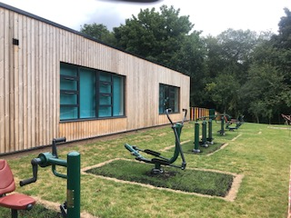

Day | Monday | Tuesday | Wednesday | Thursday | Friday
Year Group  12.20 - 12.50  12.50 - 1.20 | Reception  Year 4 | Year 2  Year 5 | Year 1  Year 3 | Year 1  Year 6 | Year 2  Year 4

Wellbeing Ambassadors’ Timetable

Please wear your yellow cap and have your lunch straight away at 12.30pm. Thank you.

Day | Monday | Tuesday | Wednesday | Thursday | Friday
Zone 1 Reading Area

Zone 2
Games Zone

Zone 5
Tyres

Zone 7
Various

Support/Substitute if needed

