**St Michael’s CE (A) Primary School**

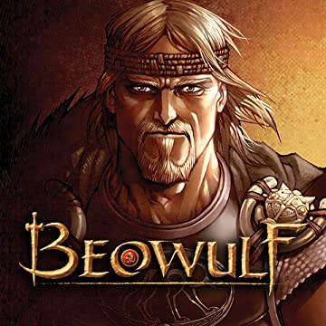**Topic Termly Overviews**

**Year:** 4

**Topic: Angle-Land**

**Term: Summer**

|  |  |
| --- | --- |
| **Subjects** | **Objectives/Learning intentions** |
| **Art**  Beowulf Paintings | **To develop ideas**   * Develop ideas from starting points throughout the curriculum. * Collect information, sketches and resources. * Comment on artworks using some visual language.   -colour  -line  -tone  -texture  -shape  **To master techniques**  **Drawing**   * Sketch lightly (no need to use a rubber to correct mistakes).   **Painting**   * Use a number of brush techniques using thick and thin brushes to produce shapes, textures, patterns and lines. * Mix colours effectively. * Use watercolour paint to produce washes for backgrounds then add detail. * Experiment with creating mood with colour.   **To take inspiration from the greats (classic and modern)**   * Describe the work (including own sketches) of notable, artists, artisans and designers. * Replicate some of the techniques used by notable artists, artisans and designers. * Create original pieces that are influenced by studies of others. |
| **DT**  Food – prepare an Anglo-Saxon feast | **To design, make, evaluate and improve**  **Food**   * I can plan and prepare a variety of healthy dishes (predominantly) using a range of cooking techniques and ingredients.   **To master practical skills**  **Food**   * I can work in a safe and hygienic way e.g. tying hair back, wiping work surfaces, and not mixing up utensils. * I can weigh and measure my ingredients accurately. * I can select and am beginning to use the appropriate equipment to prepare foods in a variety of ways e.g. sieve, grater, knife, potato peeler and whisk.   **To take inspiration from design throughout history**   * I can identify some of the great designers in all of the areas of study to generate ideas for designs. |
| **Geography**  The UK – the place where we live  Carding Mill Valley/Church Stretton and an area in Italy | **To Investigate places**   * Ask and answer geographical questions about the physical and human characteristics of location. * Use fieldwork to observe and record the human and physical features of a local area using a range of methods including sketch maps, plans and graphs and digital technologies.   **To investigate patterns**   * Understand some of the reasons for geographical similarities and differences through studying the human and physical geography of a region of the United Kingdom and a region in a European country.   **To communicate geographically**   * Describe key aspects of:   physical geography, including: rivers, mountains and the water cycle.  human geography, including: settlements and land use. |
| **History**  Anglo-Saxons | **To understand chronology**   * Place events from a period studied on time line * Use terms related to the period and begin to date events * Understand more complex terms eg. BC / AD   **To build an overview of world history**   * Use evidence to reconstruct life in time studied * Identify key features and events of time studied * Offer a reasonable explanation for some events   **To investigate and interpret the past**   * Choose relevant material to present a picture of one aspect of life in time past * Ask a variety of questions * Use the library and internet for research * Look at the evidence available * Use text books and historical knowledge   **To communicate historically**   * Use appropriate historical vocabulary to communicate, including:   Dates  time period  era  change  Chronology.   * Recall, select and organise historical information      * Communicate their knowledge and understanding * Use literacy, numeracy and computing skills to a good standard in order to communicate information about the past. |
| **English Links** | Non-chronological report on Anglo-Saxons, retelling of Beowulf / first person work based on characters in Beowulf story. |